The aim of this report is to investigate the possibility of combining the transmuter and liquidity provision into one thing, how that would be done, the potential benefits and the potential problems.

Outline

The Alchemix transmuter takes in AL(coin(eth/dai/btc/…)) (ALC) and converts that into (coin) (C) over time.

The curve pool provides liquidity to the project allowing the swapping between ALC and C

The coins that people want are the C coins denominated in an ALC debt, so people borrow coins and sell the ALC into curve so they can get out the C that they really wanted.

Alchemix allows the repayment of debt in ALC or C so the liquidity is only needed on one side of the bridge from ALC to C as that is most of the direction of the swap (if you exclude arbitrage).

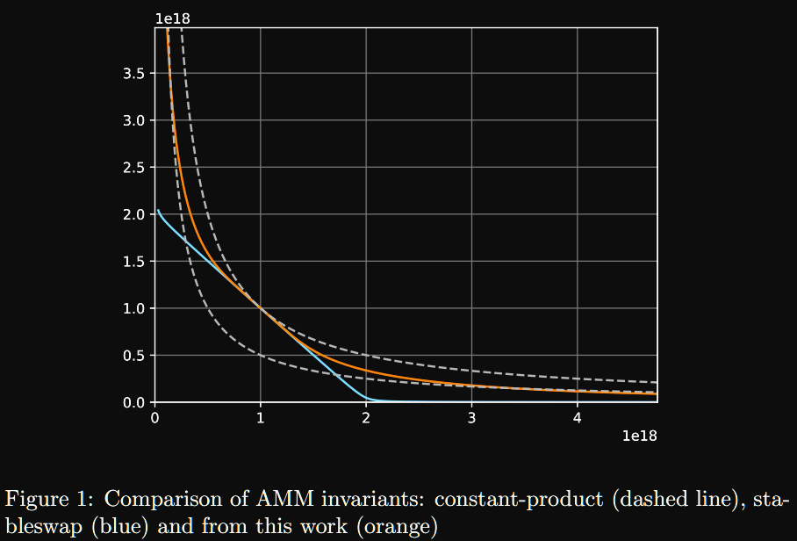

The opportunity:

To combine the stability feature (transmuter) with the LP provision to increase the capital efficiency, boost liquidity and provide better returns for the LPers

Ma vision ser if you would please:

So, u get a curve pool w a 10:5:85 ratio for ALC:C:yearnC(ratio included so as the dai returns go up the overall liquidity in the system increases and the LPers get more mulah)

95% of the C is in the yearn pool

How it gets used:

#people borrowing#

As people borrow they can choose to automatically swap into C

But if ur making a thic purchase then you can choose to withdraw ur yearnC and swap that into dai also (only matters if you have a lot of money and the extra gas cost wont matter to you

Note: the C:yearnC ratio is counted as one thing and handled automatically like if its greater than x% of the dai amount then u draw from the C:yearnC pools proportionally to keep good liquidity so small transactions save on gas and people cant game the system

#daily yearn call thingy#

When the yearn value yield thingy is run:

Pays down debts

Buys up enough ALC to keep the ration

allocates the same amount of dai to the C side

Removes enough Dai from the yearn vault to keep that 5% peg for the C side

#lpers#

Deposit ALC or C or yearnC

Gets LP token…

how did you think is was going to work

effects of this:

* the LPers make more money, cus most of their C position is being yield farmed
* better liquidity because there is more C available to buy
* there is more C in the ALCX system meaning even more boosted yield for the borrowers